PRODUCT REQUEST FORM
PRODUCT NAME: | Fingernail Cleaner
DESCRIPTION OF REQUEST:  - New Product  - Modification  - Product Extension  - Country addition  - Label Change  - Intended Use  -…Etc… | Fingernail Cleaner, designed to address a critical yet often overlooked gap in aseptic hand hygiene protocols within compounding pharmacies. This project represents a targeted sourcing initiative to enhance our portfolio’s compliance-driven value proposition.  Project Background  The U.S. compounding pharmacy market, valued at $15.6 billion, relies on a consumables segment worth $2.34 - $3.12 billion. and a projected CAGR of 7% (2025~2035). Core to pharmacy operations is strict adherence to USP <797> and <800>, Effective hand hygiene is essential to prevent microbial contamination during sterile and hazardous drug compounding. The Fingernail Cleaner supports these operational and regulatory requirements.  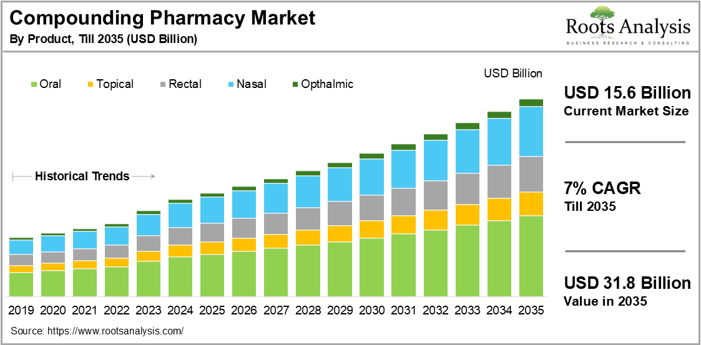
PURPOSE OF REQUEST: | ☐Complaint No. ☐Supplier ☒New market_______US_________  ☐Customer ___ ☐Internal _ ☐Other________________________  Add details:
ESTIMATED BENEFITS: | ☒ Financial Benefit:__Complete the product lines for the Compounding Pharmacy markets, Annual sales amount 150K__ (Mandatory For NPD request)  Estimate the potential increase in cash flows, revenues, or any other financial benefits  ☐ Cost Saving:__________  Decrease in the cogs, transportation or operation expenses, or any other cost-saving opportunities  ☐ Improved Operational Efficiencies:_________  Decrease in the Lead time, delivery time, MOQ, Inventory, or any other efficiency improvement  ☐ Non-Financial Benefits:_________  Quality Improvement; Enhanced customer satisfaction, product competition, Brand reputation, etc.  ☐ Other Benefits:__________
PRODUCT DESCRIPTION:  - Functional performance requirements  - Appearance  - Any unique points of differentiation against similar competitor product lines  . ..Etc… | Product Definition & Scope 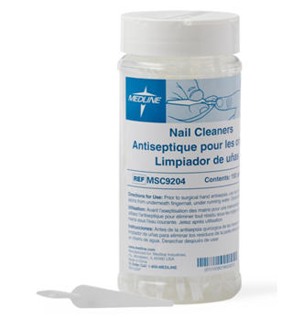  Product: Disposable Fingernail Cleaner.  Primary Use: For the mechanical cleaning beneath fingernails as part of a comprehensive aseptic hand preparation protocol, prior to gowning and entering ISO 5 cleanrooms or handling sterile components.  Key Sourcing Specifications: We will target manufacturers capable of providing:  - Material & Design: Made from medical-grade polymers with an effective design for debris removal. Ergonomic for ease of use.  - Compliance Support: Supplied with documentation suitable for supporting end-user SOPs aligned with USP chapters.
REQUEST TYPE | ☐LCR (Labelling Change Request)  Changes on the labels without changing the products  ☐SCR (Supplier Change Request)  Change applications initiated by Suppliers  ☐ECR (Engineering Change Request)  Existing products that SOLM is the legal manufacturer  Engineer changes that are not bringing new hazards/risks  ☐NPD (New Product Development)  Develop new innovative products that SOLM will be the legal manufacturer  Significant changes on existing products that may bring new hazards/risks or new intended use  Change products from outsourcing to SOLM to be the legal manufacturer  Development of VET/Component products  ☐SDP (SOLM Distributor Product)  New product introduction that SOLM will not be the legal manufacturer  No change on the product, no SOLM information on the labels  ☒SPP (SOLM Portfolio Product)  New product introduction that SOLM will not be the legal manufacturer  No change on the product, Add SOLM information on the labels  ☐Customized Product / Market  Purchased products that SOLM is not the legal manufacturer  Engineering change on products or new customized products requested by SOLM  New Market region requested by SOLM
TARGET MARKET: | ☒ US ☐ Canada ☐ EMEA ☐ UK ☐ Brazil ☐ Australia & New Zealand ☐ Other countries/regions, list:
TARGET USE: | ☒ Human Use  ☐ Animal Health | STERILE | ☐ YES  ☒ NO
VOLUME/SALES OPPORTUNITY: | Launch volume required: | Yr 1 estimate | Yr 2 estimate
CUSTOMER NOTIFICATION | Do we have any special quality agreement in place with customer which requires approval before implementing changes? ☐ YES ☒ NO  If Yes, please provide the customer's name and evidence.  Attach the customer confirmation GF-0083 at the end of the form.  Is notification to the customers needed after change project is closed? ☐ YES ☒ NO  Remark:  Example: change affect regulatory, performance, appearance, etc. Notification method.
LEGAL MANUFACTURER: | ☐ Sol-Millennium  ☒ Other: __________ | BRANDING | ☒ Sol-Millennium  ☐ Private Label
EXPECTED PRODUCT LAUNCH PERIOD: | ☒ < 1 year  ☐ 1-3 year  ☐ > 3 years | EXPECTED PRODUCT LIFE PERIOD: | 10 years
NAME AND DATE of REQUEST: | Alex Lu 2026/2/9

Business Case & Commercial Rationale

Product | COO | Medline Uni Price | Target Uni Price | Target Gross Margin | Annual consumption in US | Solm采购量（10% ） | Est. Sale Revenue
Fingernail Cleaner | China | $0.12 | $0.10 | 35% | 15,000,000 | 1,500,000 | 150,000

